Chat GPY - AI Chat

Looking for an intelligent and engaging chat companion? Look no further than Chat GPY, the artificial intelligence chat bot trained by OpenAI powered by GPT-3 technology. With its powerful human-like conversational capabilities, Chat GPY can answer a wide range of questions and engage in meaningful dialogue. From answering basic science and life questions to composing emails, writing essays, and even coding and gaming, Chat GPY is a versatile and entertaining chat partner. And with the Chat GPY for Android app, you can enjoy enhanced features and a more efficient and enjoyable chat experience.

feel free to email at devsmix@gmail.com Thank you so much!

* **By:** Kelvin Muthama
* **Email:** kelvinmutinda347@gmail.com
* **WhatsApp:** +254112949305

# How To Install On loaclhost

After downloading the project, you must install [Node JS](https://nodejs.org/) Then open **CMD** in the project file And type these commands

* **cd client**
* **npm install**
* **npm run dev**
* **Open another CMD**
* **cd server**
* **npm install**
* **npm run server**

# Change OpenAI API Key

Proper API key from OpenAI: It's possible that you are not using a valid API key from OpenAI. You can get an API key by visiting [https://beta.openai.com/account/api-keys.](https://beta.openai.com/account/api-keys)

After open website Click on Create new secret key

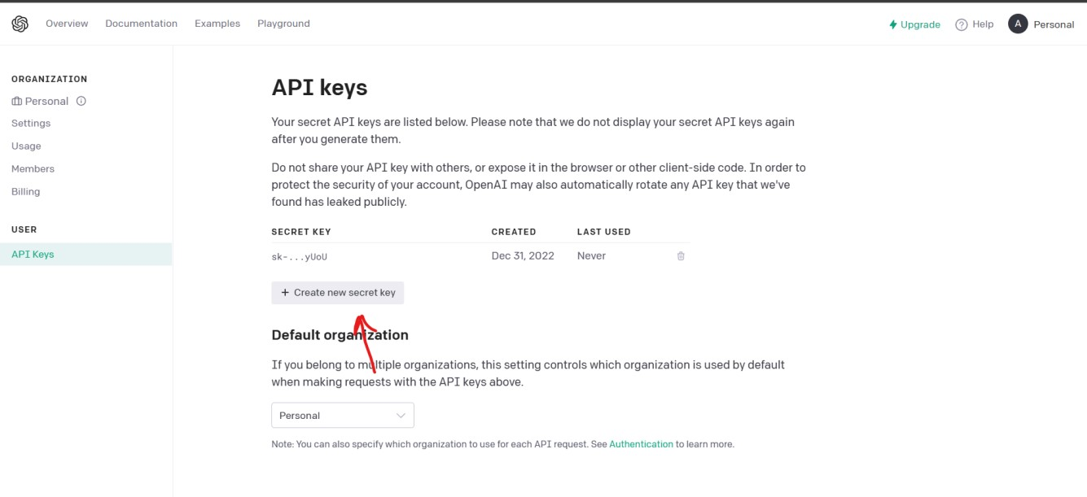

And Copy This API Key

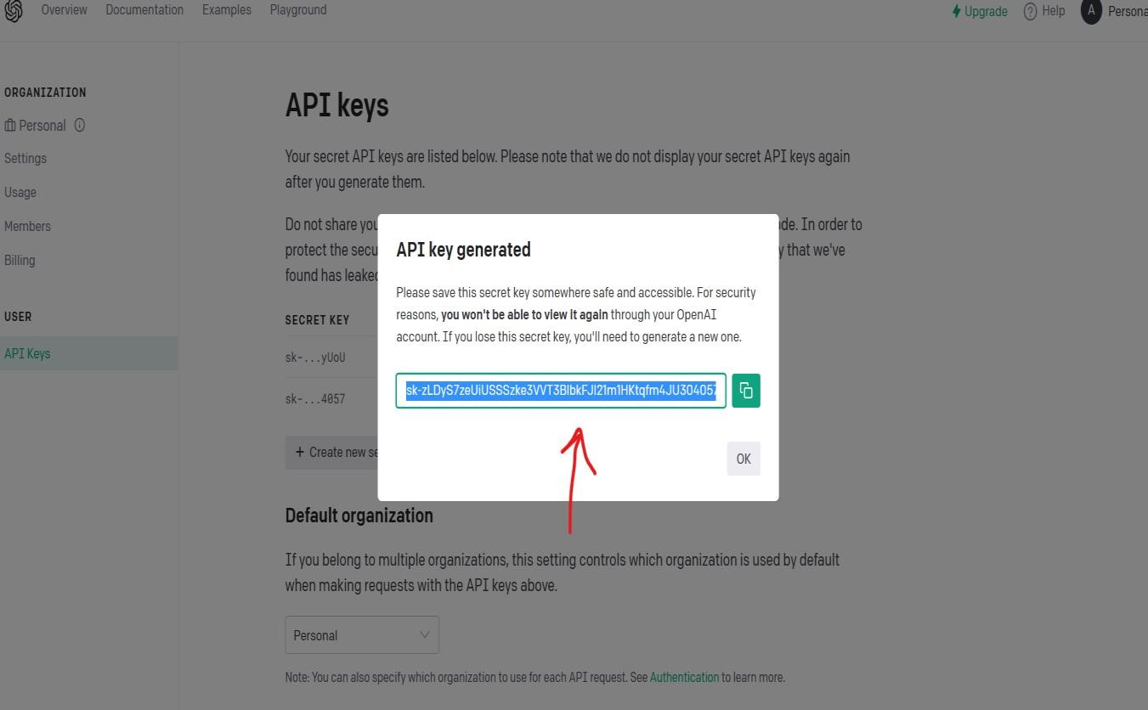

Then open the project folder **server/.env**

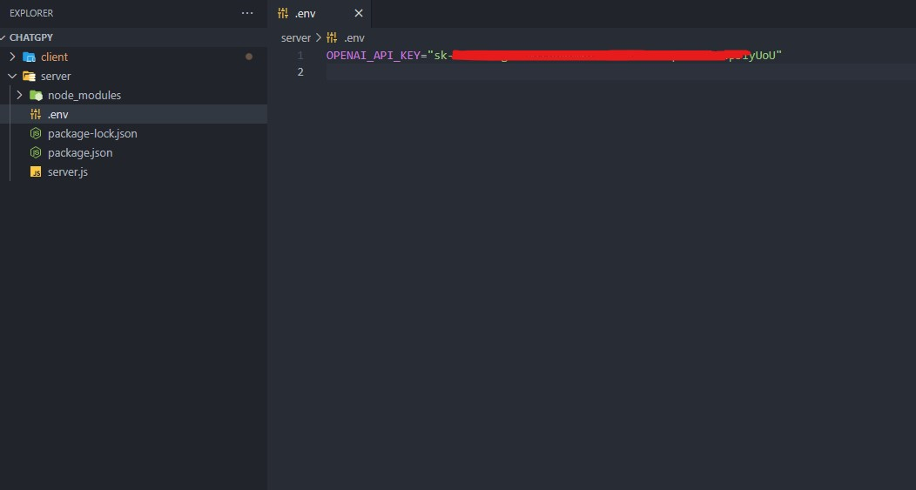

And paste API KEY

# How To Change Website Name

Open the project and find Chat GPY in all the site files and replace with the new site name

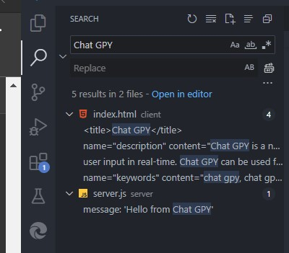

# How To Upload Website For Free Hosting

First create an account on [**GitHub**](https://github.com/) and follow the lines with pictures

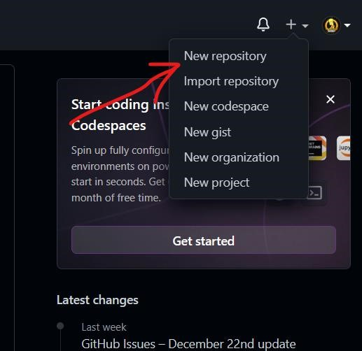



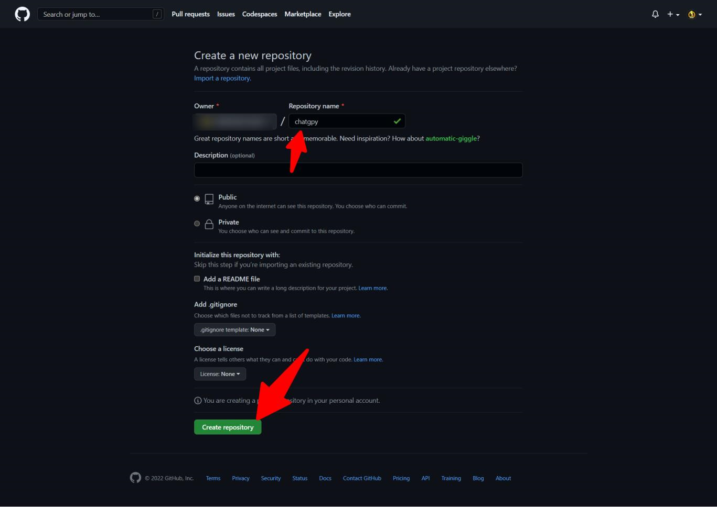

Follow the steps to upload from GitHub

After uploading, register on the **render.com** website

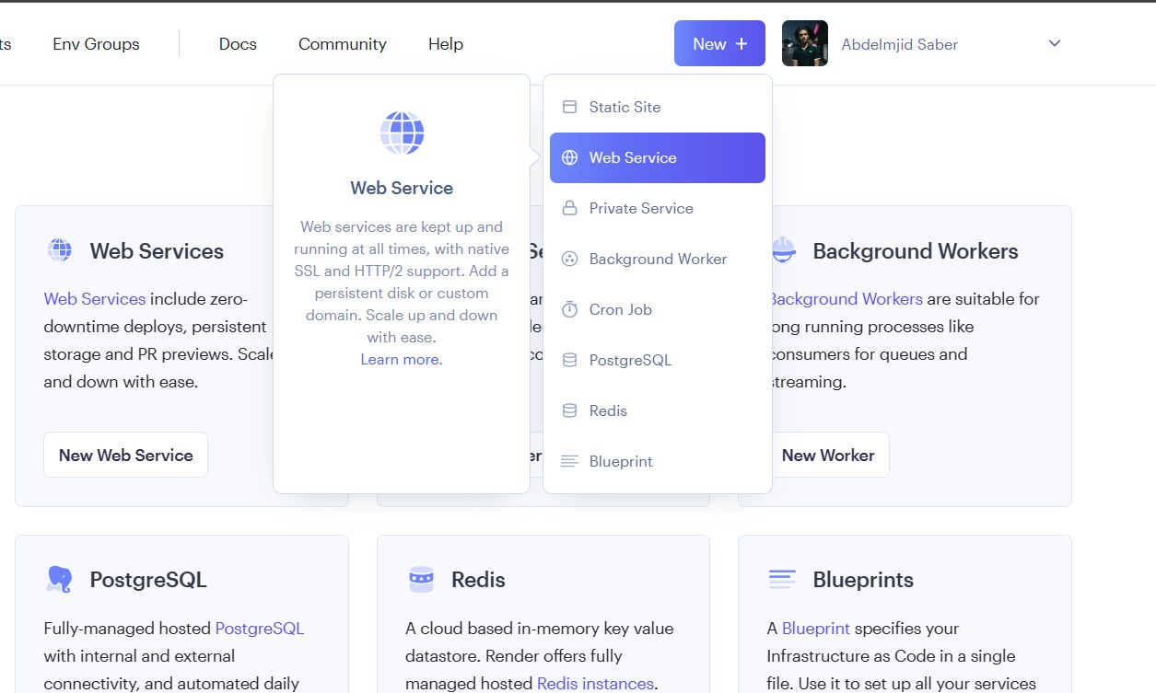

And Select **Web Service and Connect a repository**

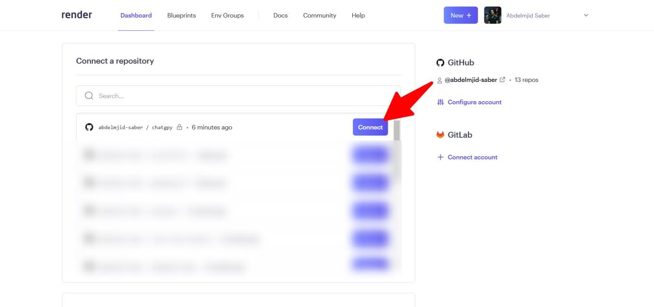

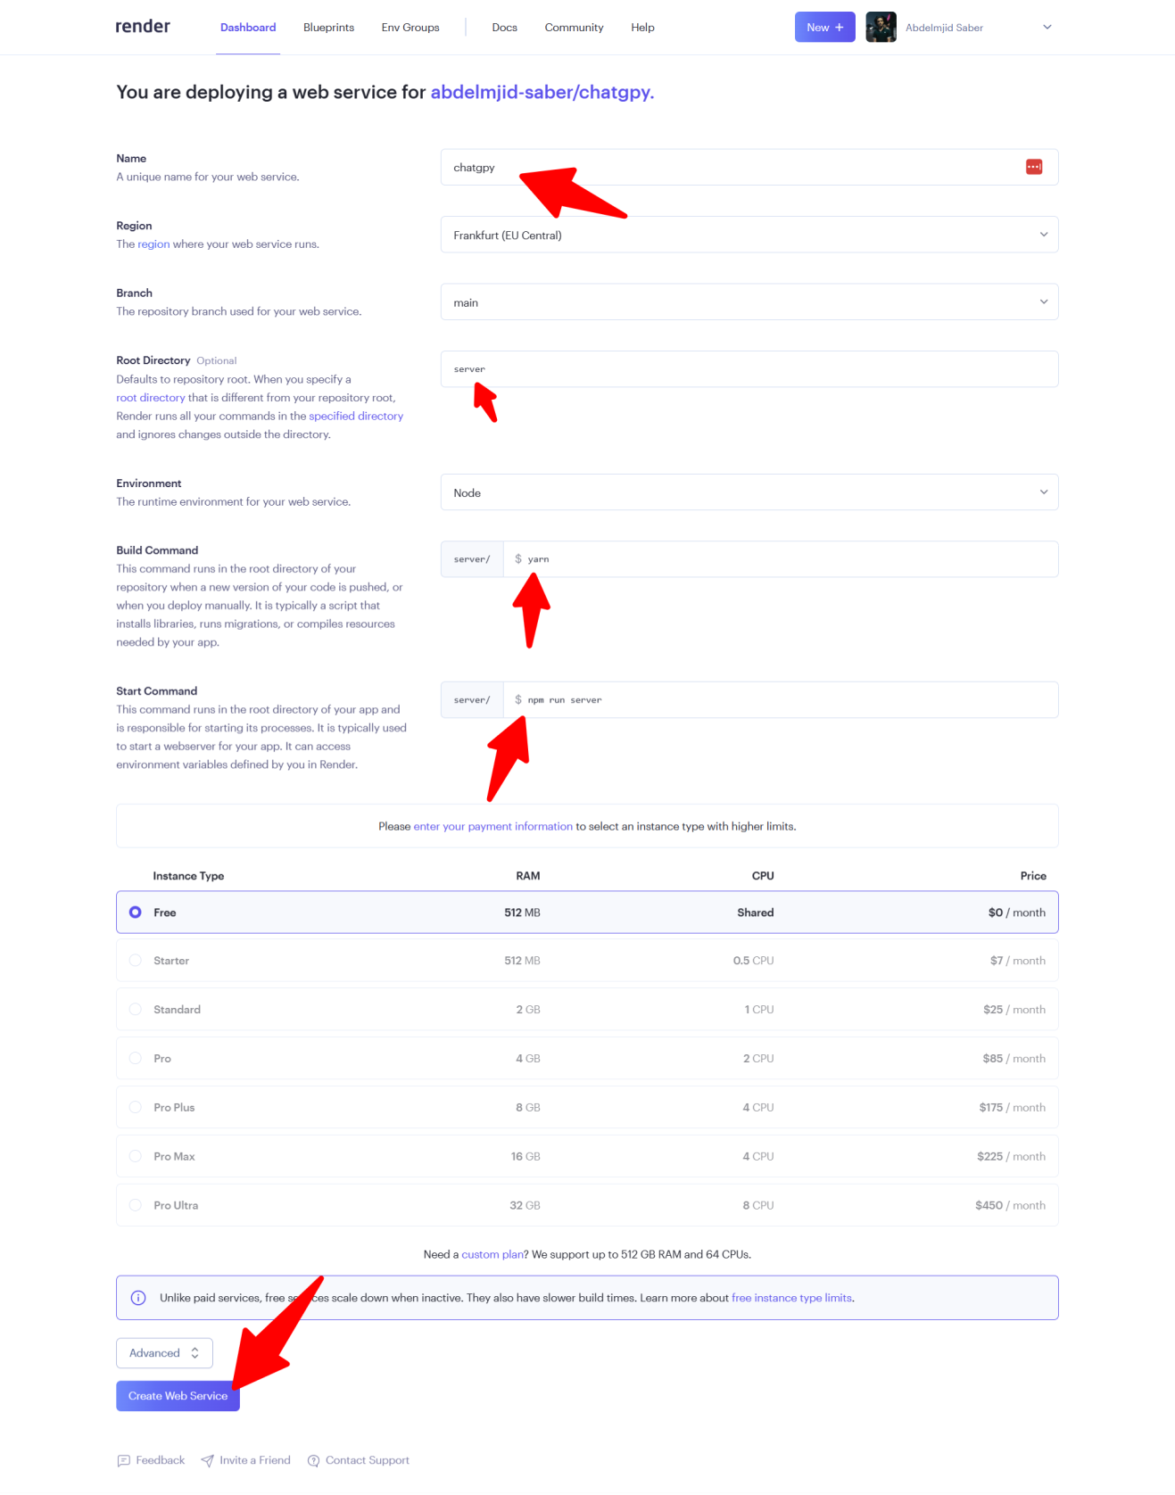

After Build Go **Environment a**nd click on **Add Environment Variable**

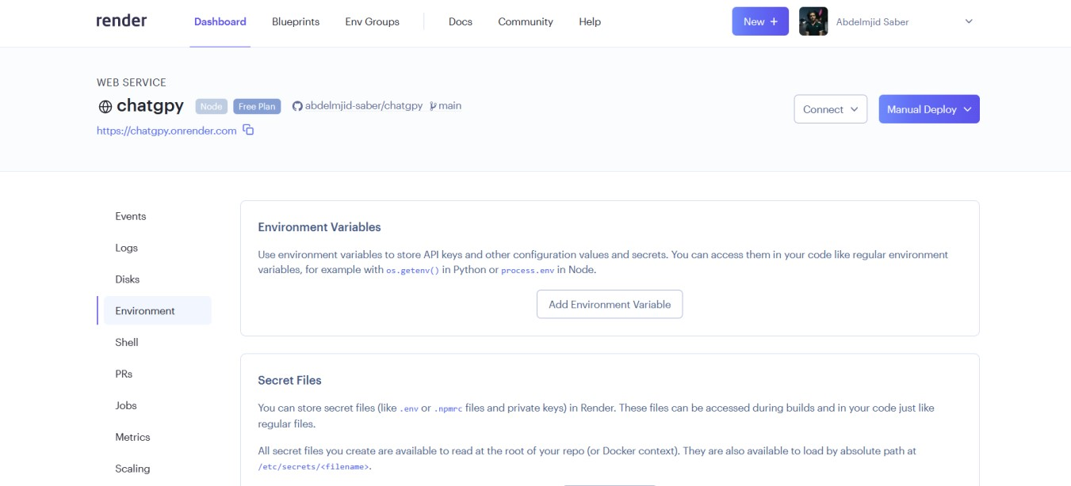

Then open the project folder **server/.env and copy this Name And API Key**



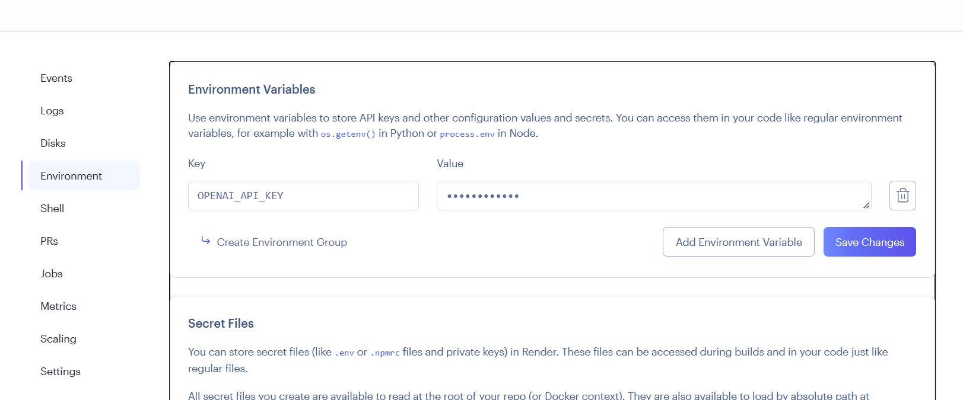

Then copy this link

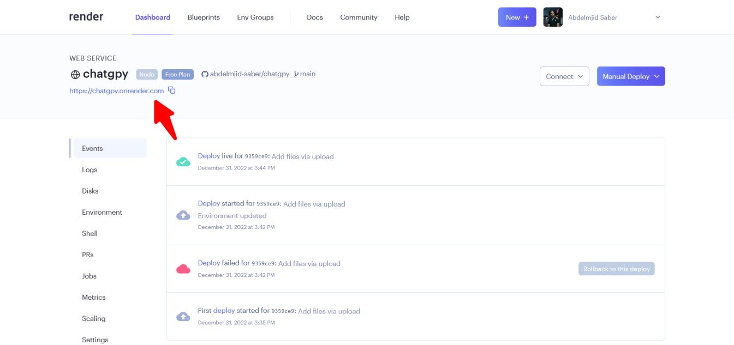

Then go to the file chatgpy/client/assets/js/main.js

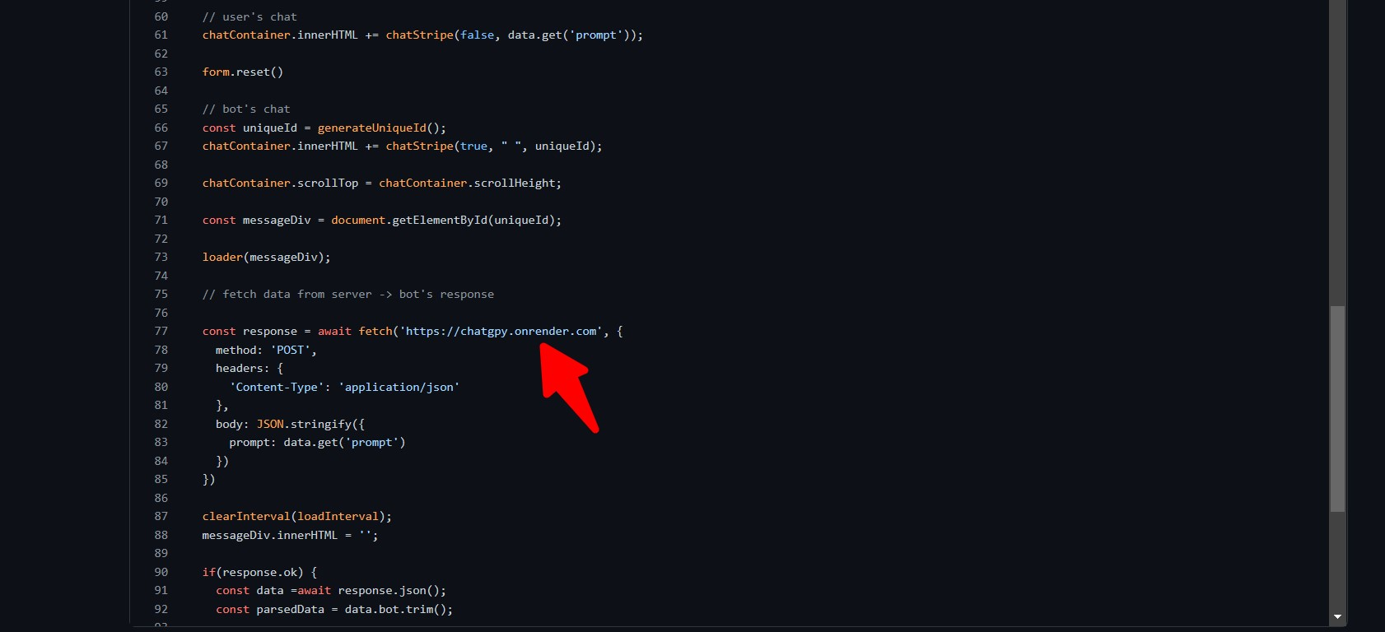

And after amending this link to your link.

Then register on the [Vercel](https://vercel.com/) website, and Import Git Repository

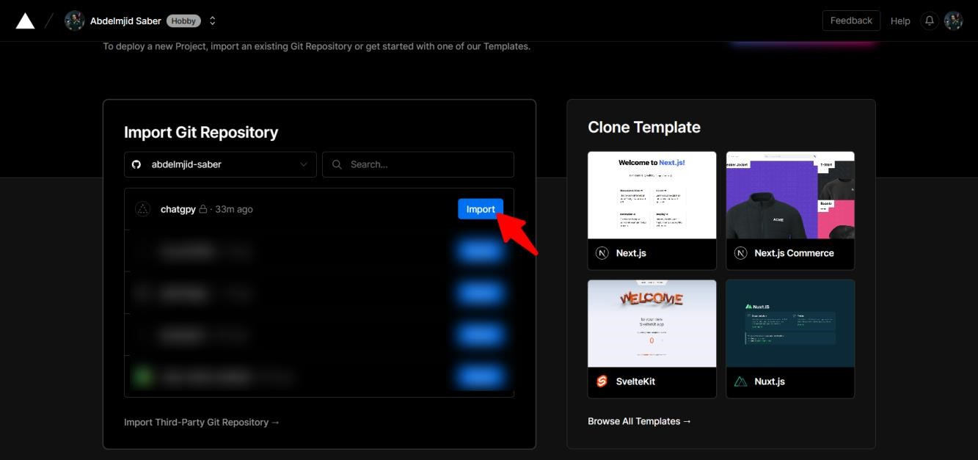

And change Root Directory to **client** , click on **Continue** and **Deploy**

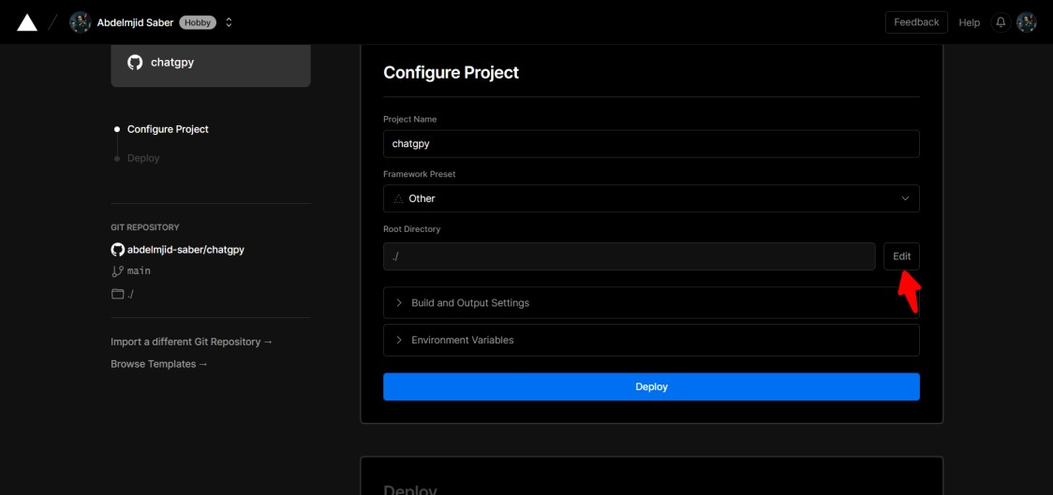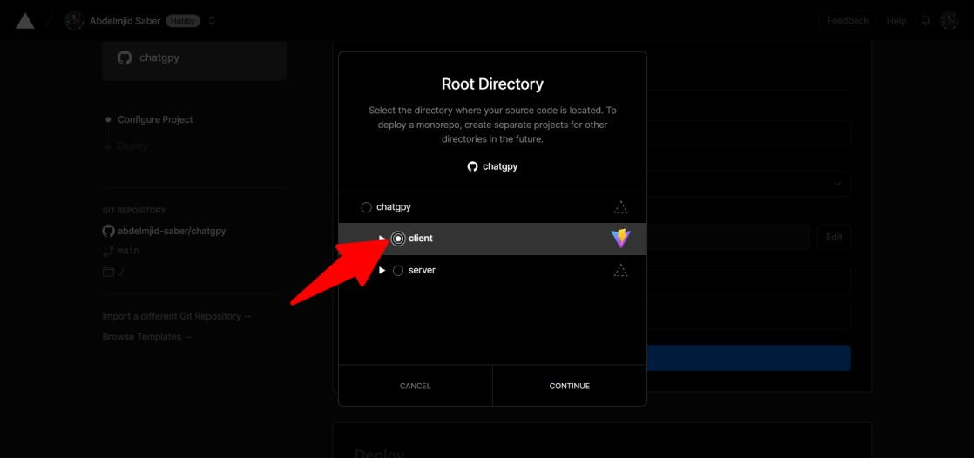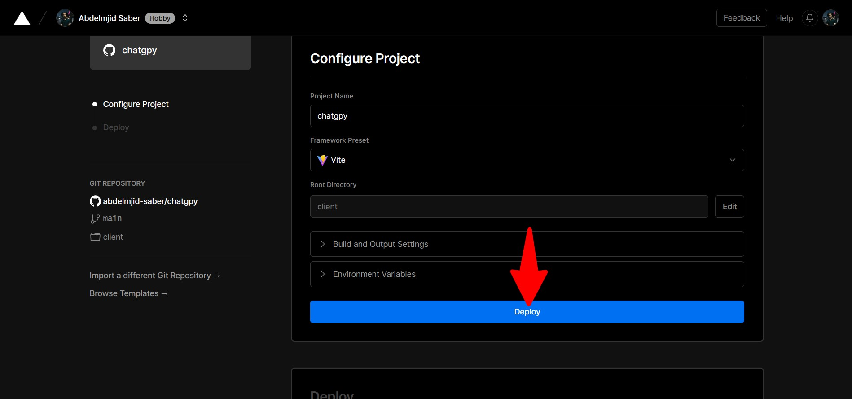

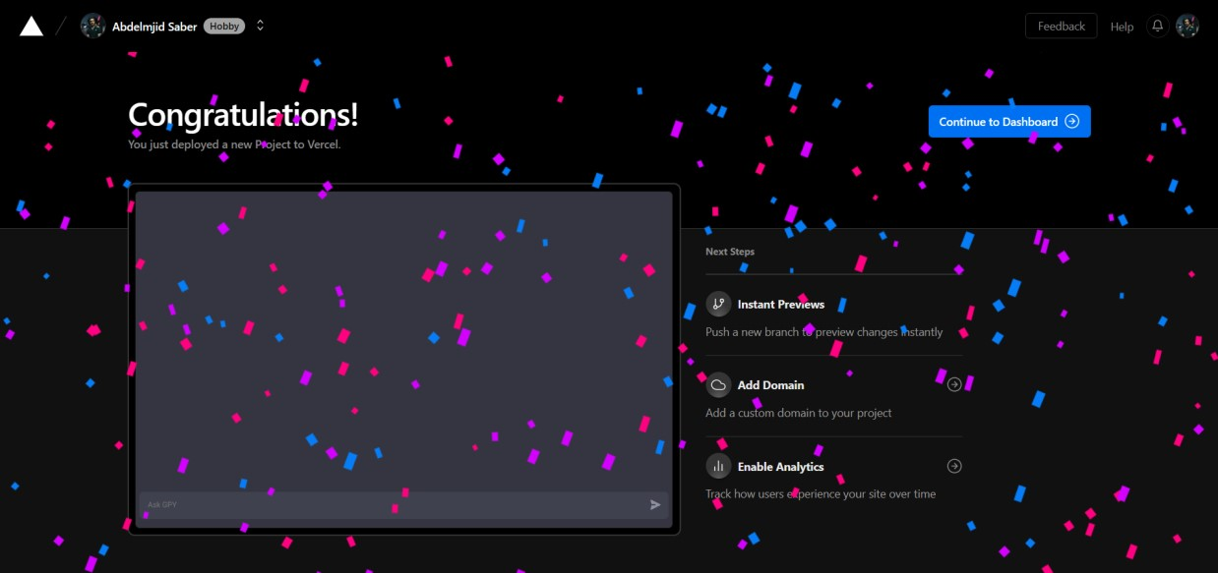

We're done

Enjoy and discover the site for yourself

And don't forget to leave a review